Ohio Summer Food Service Program
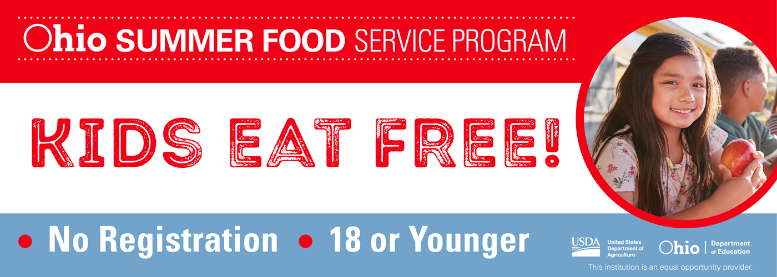
All children ages 1 through 18 are eligible to receive free meals during the summer months at participating program sites. Individuals ages 19 through 21 who have been identified as having mental or physical disabilities and are following Individualized Education Programs (IEPs) through their current enrollment in educational programs also are eligible for free summer meals.
For more information call 1-866-3-HUNGRY (486479).

Free Meals for Youth

Cincinnati Public Libraries

Free Meals for Youth through UMC Food Ministry
Mondays 3:00 pm to 5:00 pm at the Groesbeck Public Library
No Registration. First Come, First Served.
Children age 1-18 years of age and age 19-21 years with an IEP, physical or mental disability.
In an effort to combat hunger, the Library is partnering with UMC Food Ministry to bring meals for youth to select Library locations. The UMC meal service is made possible through federal funding, as part of the USDA's Child Nutrition Programs.

For a list of participating locations and details about this service, please visit cincinnatilibrary.org/meals.

This institution is an equal opportunity provider.

